**Business Location Analysis**

**Name:** Venkata Sarath Chandra Muktevi

1. Screenshot after login is:

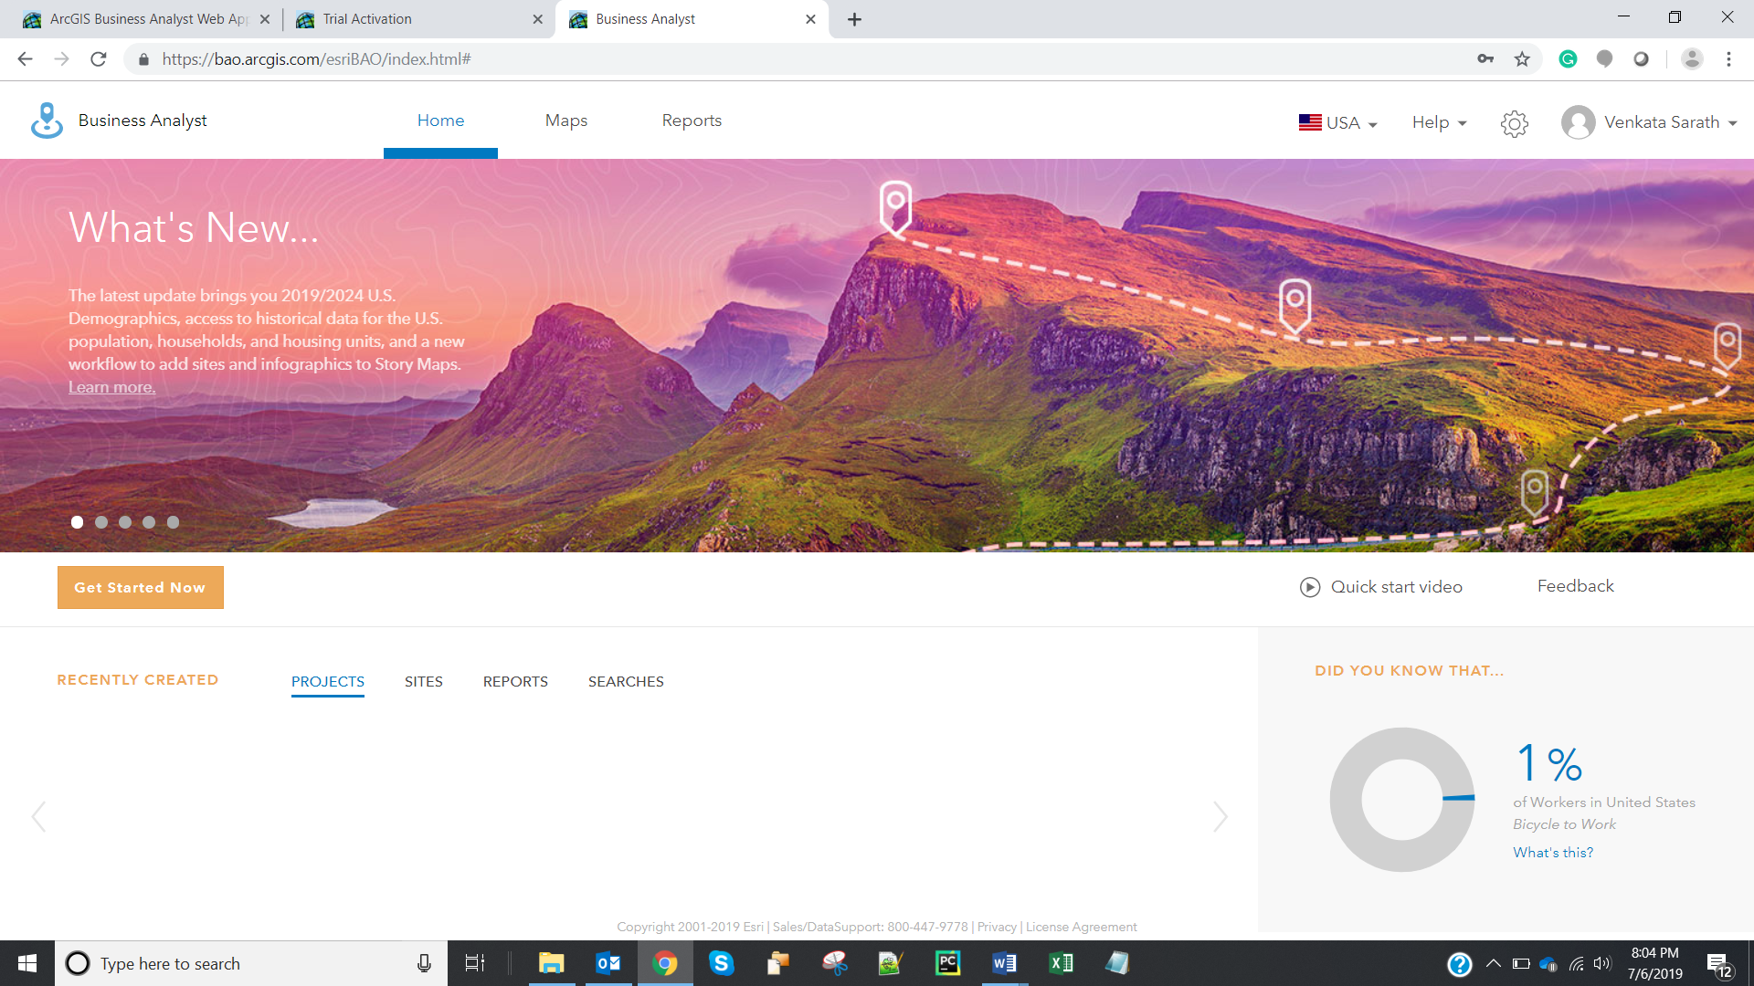

1. Screenshot of the success message after creating a new project is:

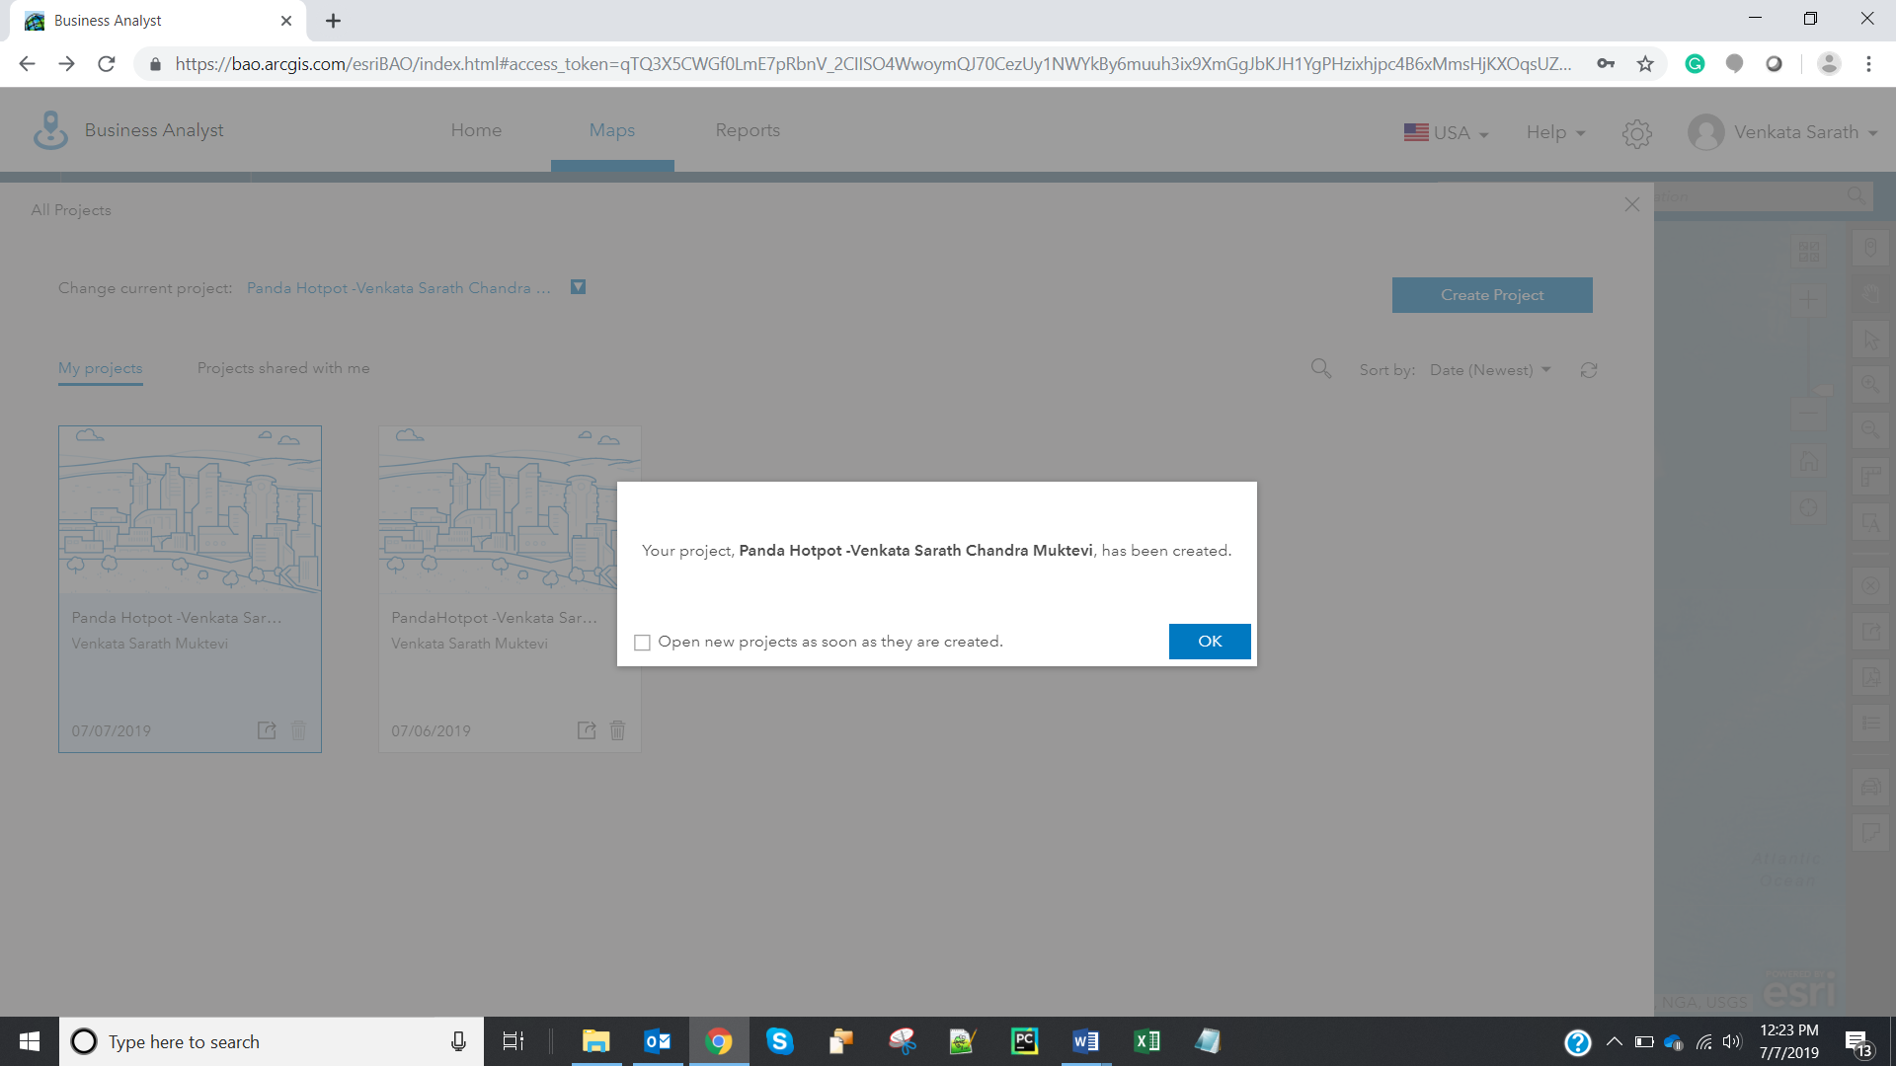

1. Screenshot highlighting the zip codes is:

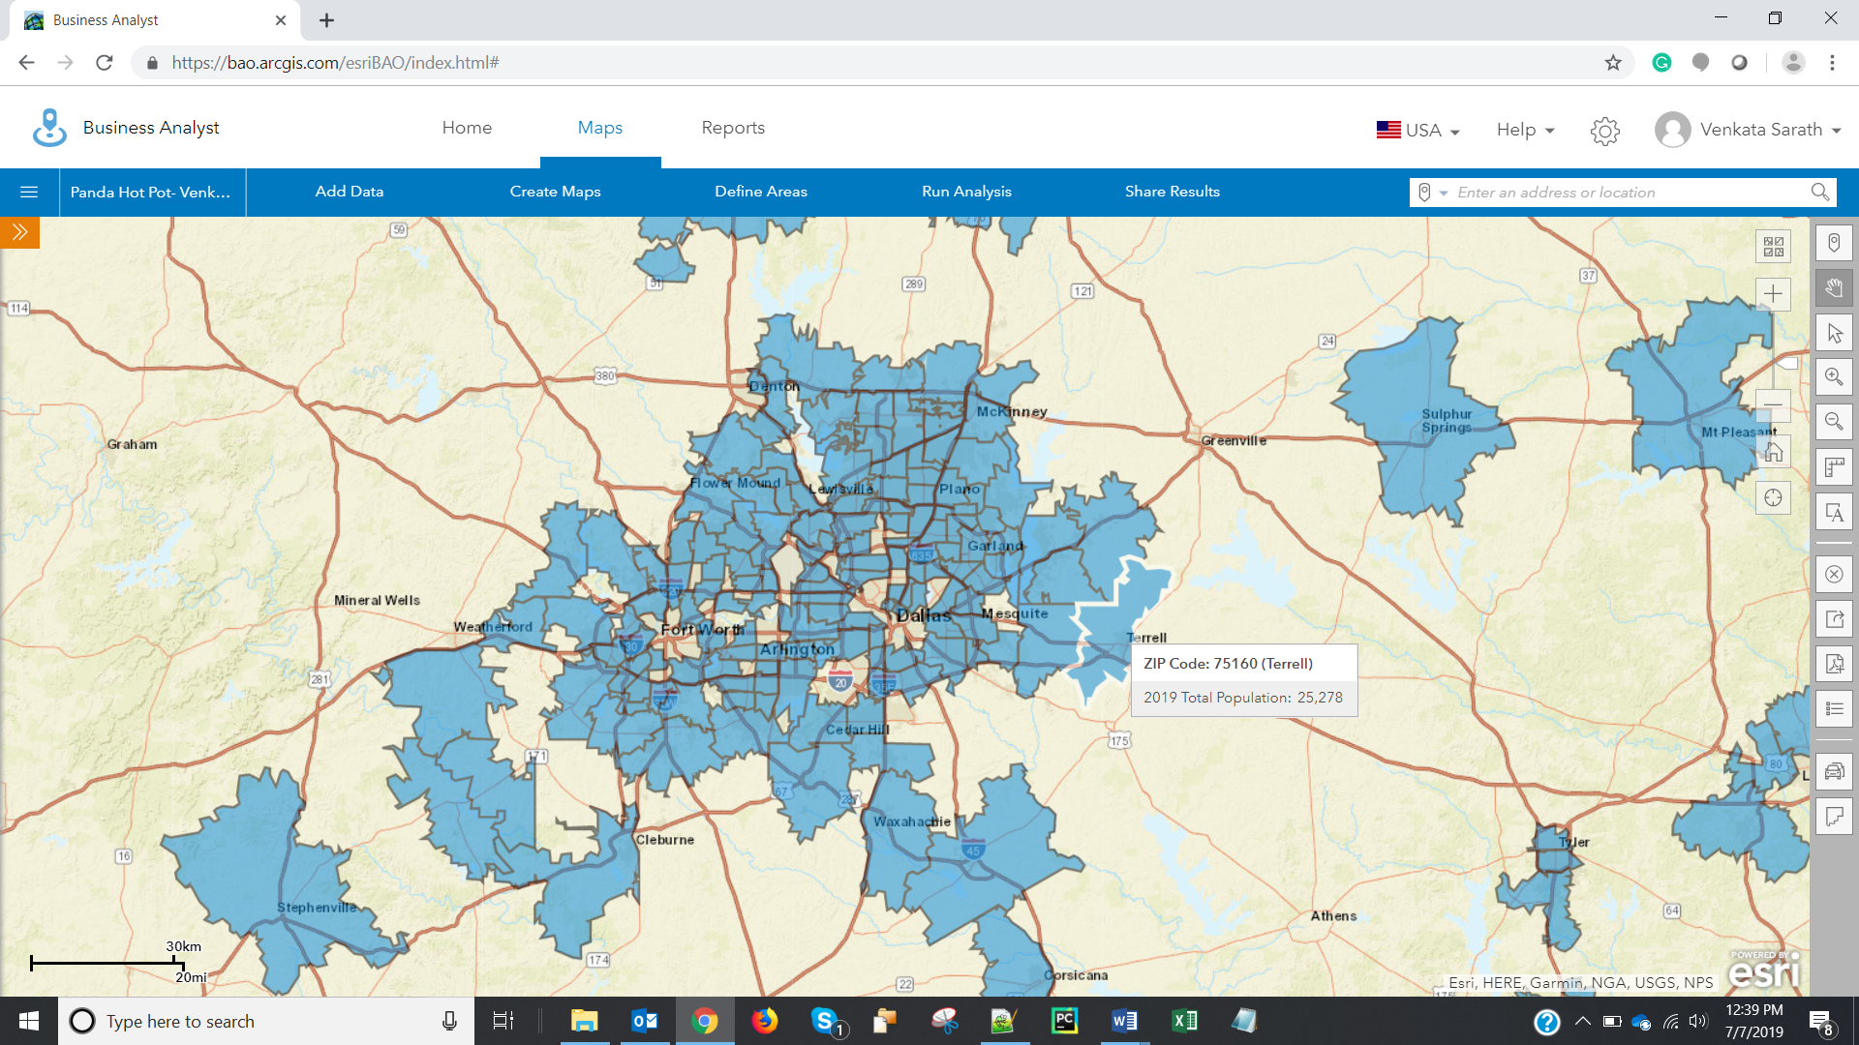

1. Screenshot after adding Asian Population variable is:

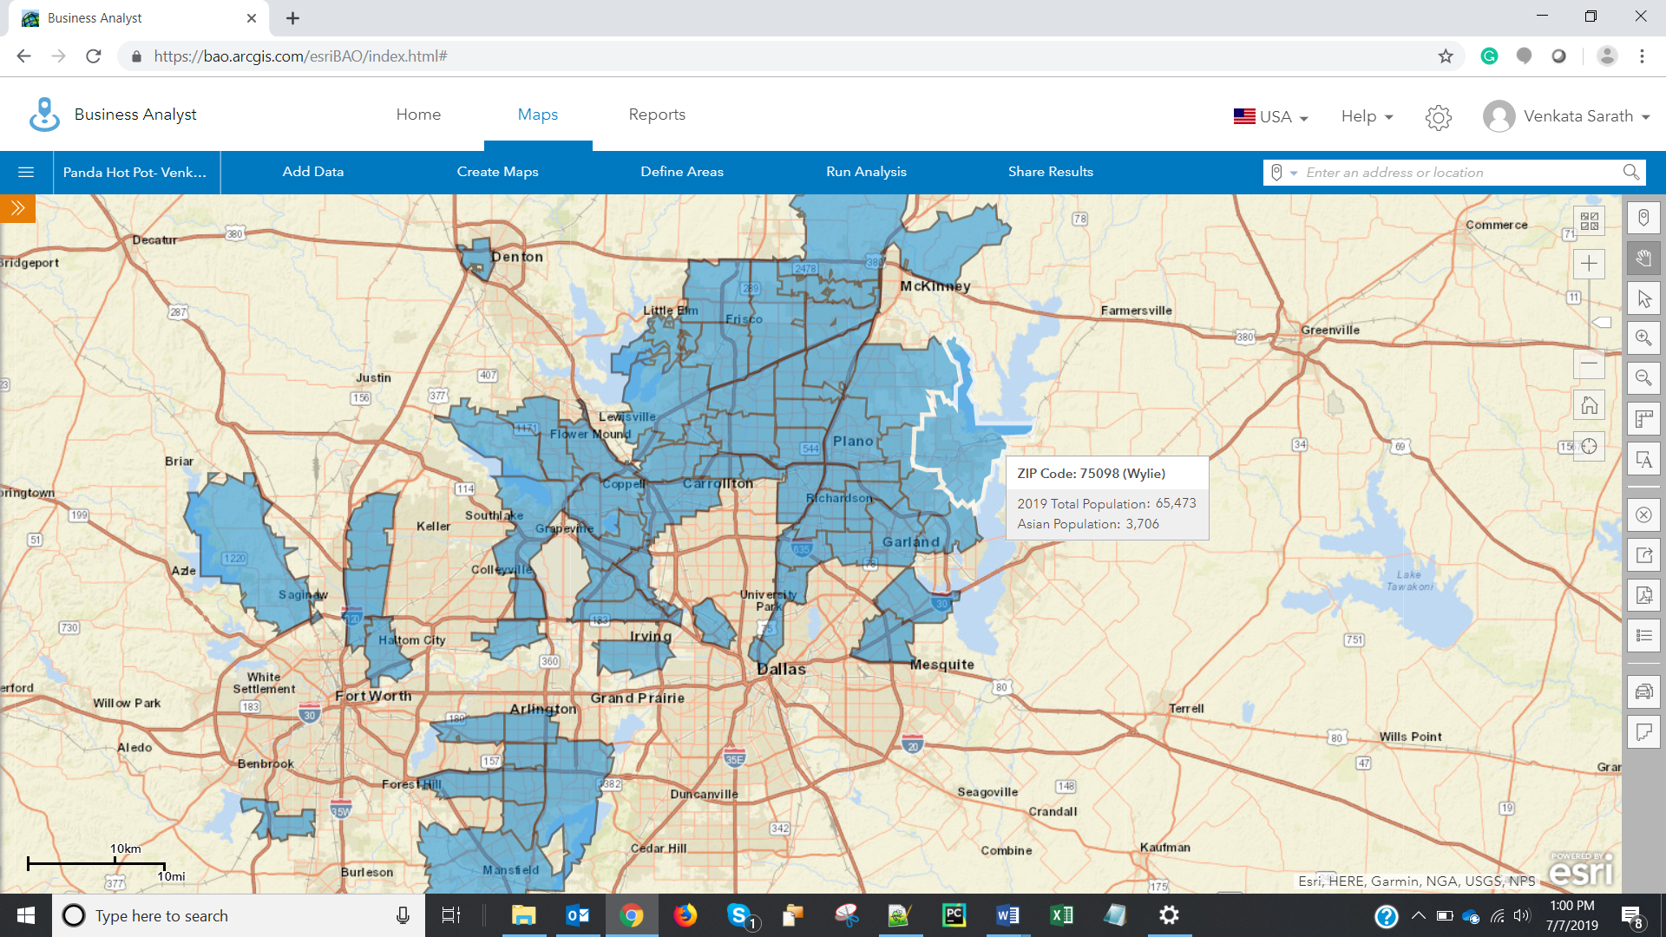

1. Screenshot showing the sliders with minimum values is:

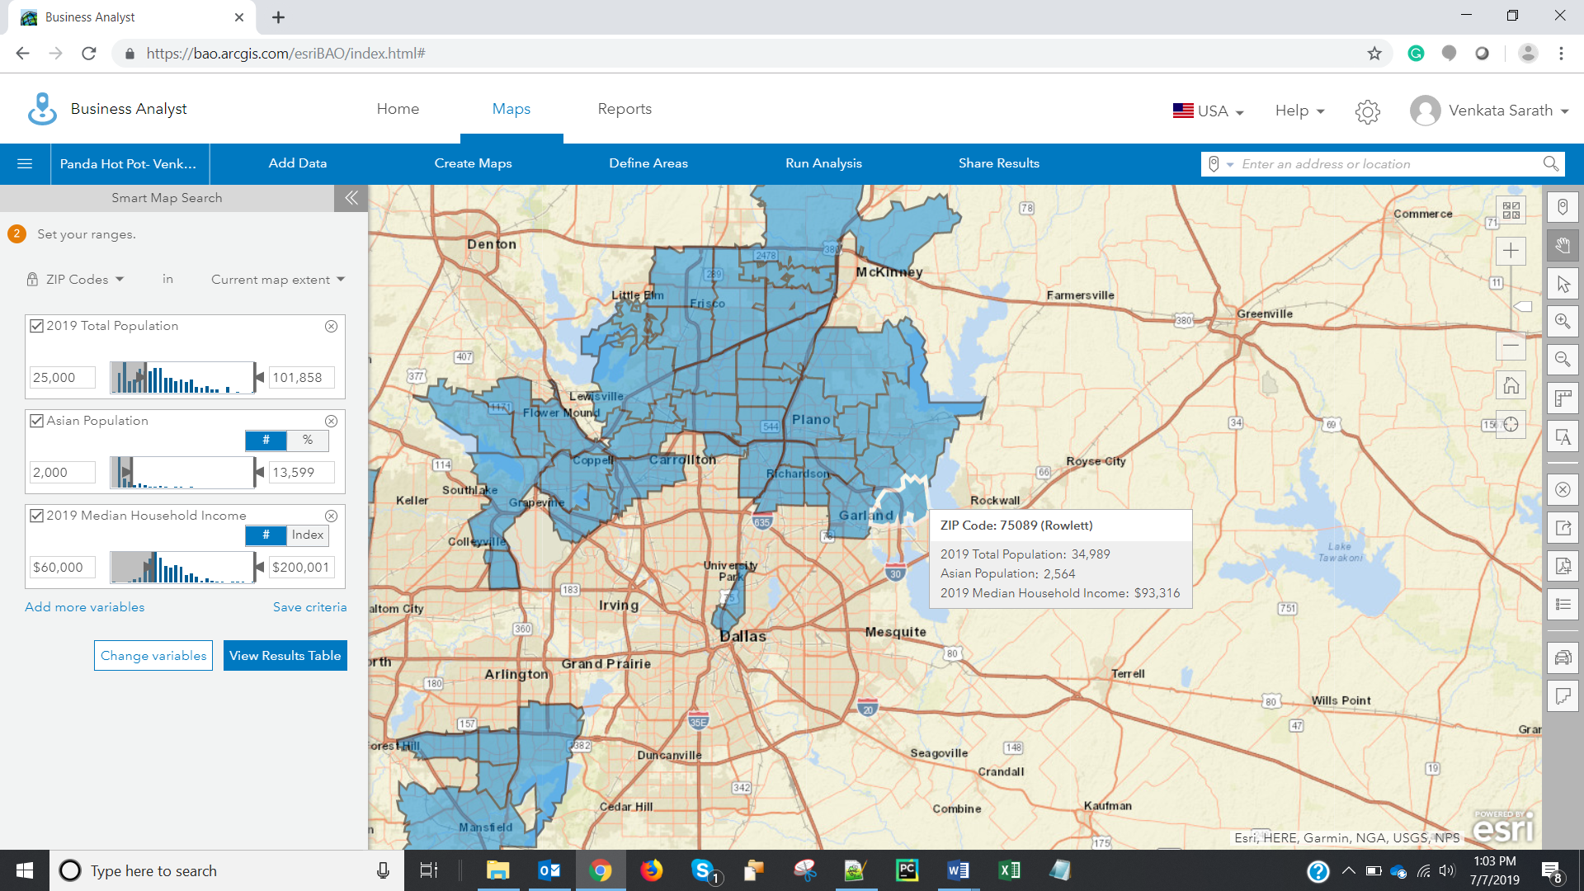

1. Screenshot of the map after placing the minimum slider values is:

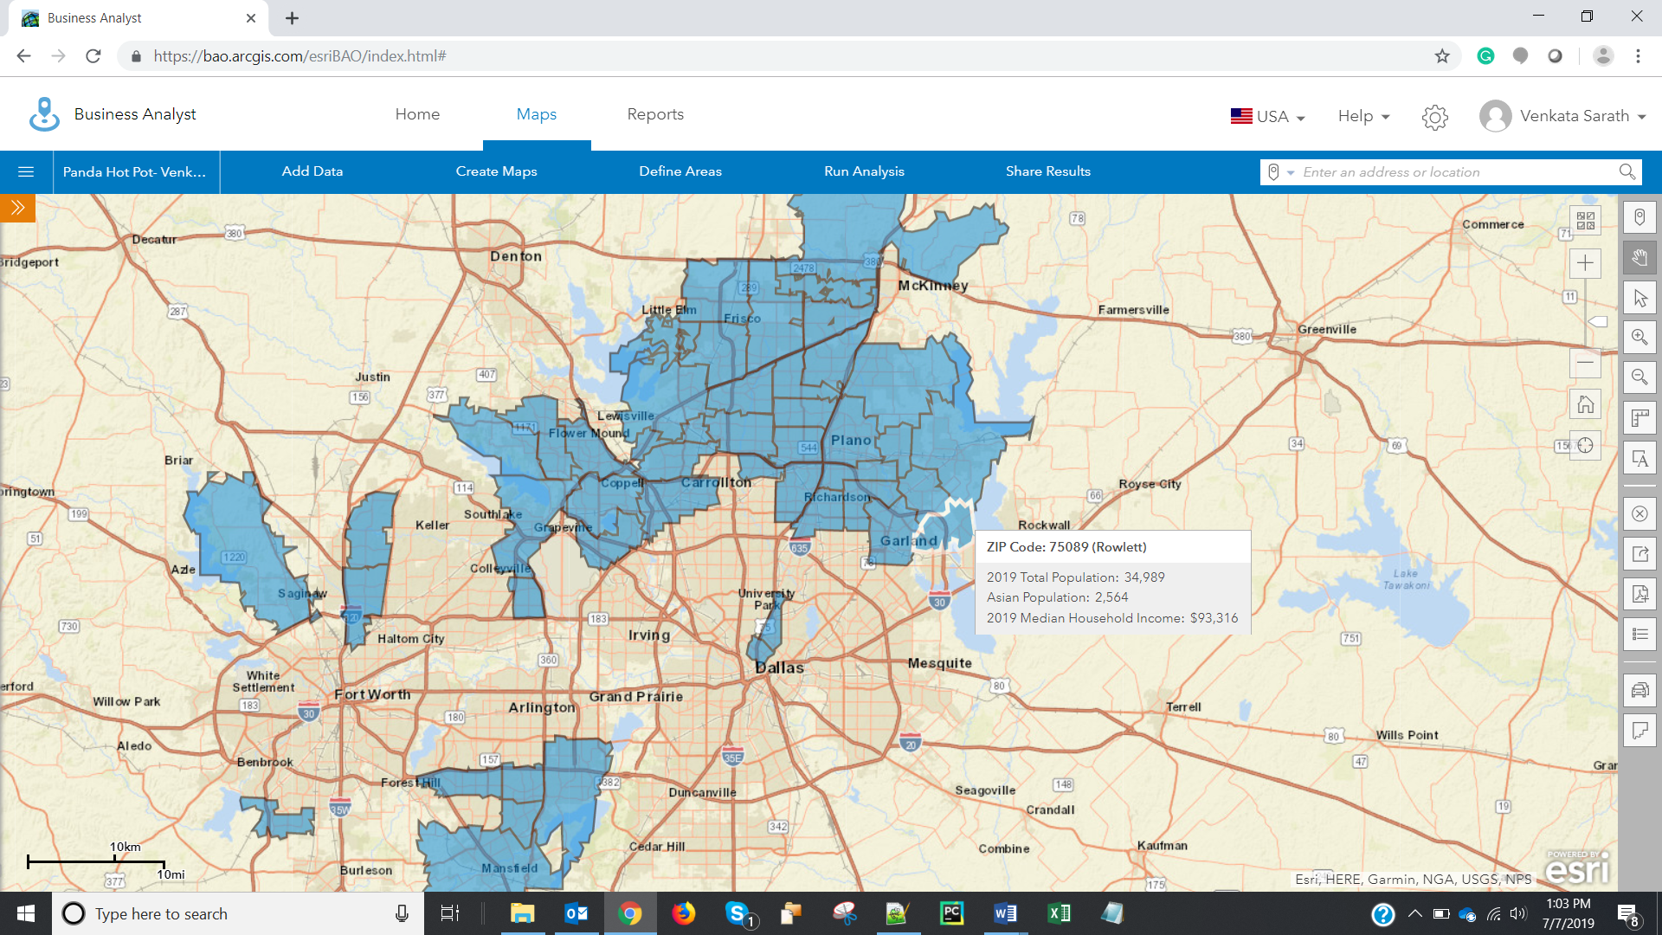

1. Screenshot of the sliders after placing Retail Potential is:

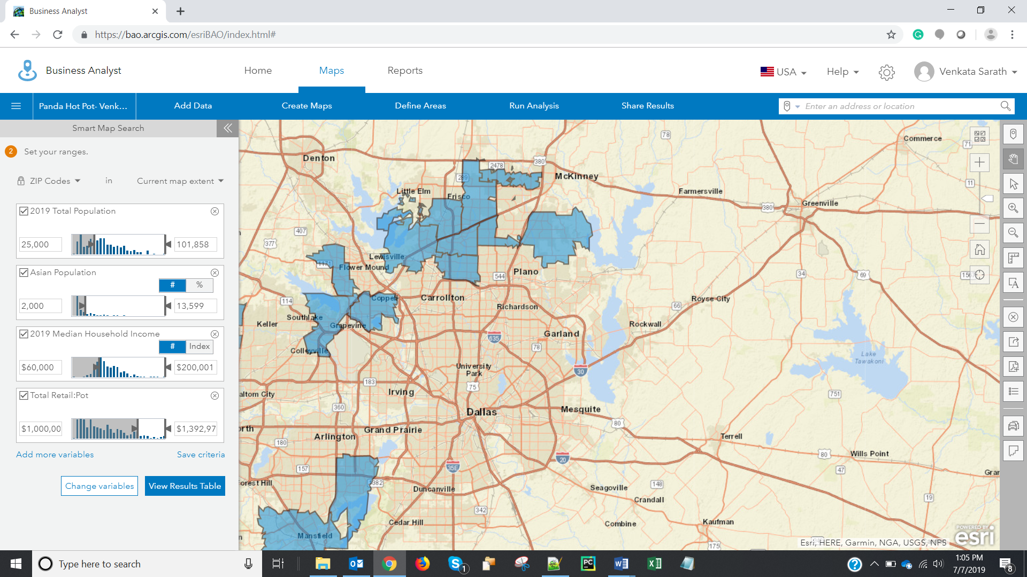

1. Screenshot of the map after placing all the minimum sliders for the 4 variables is:

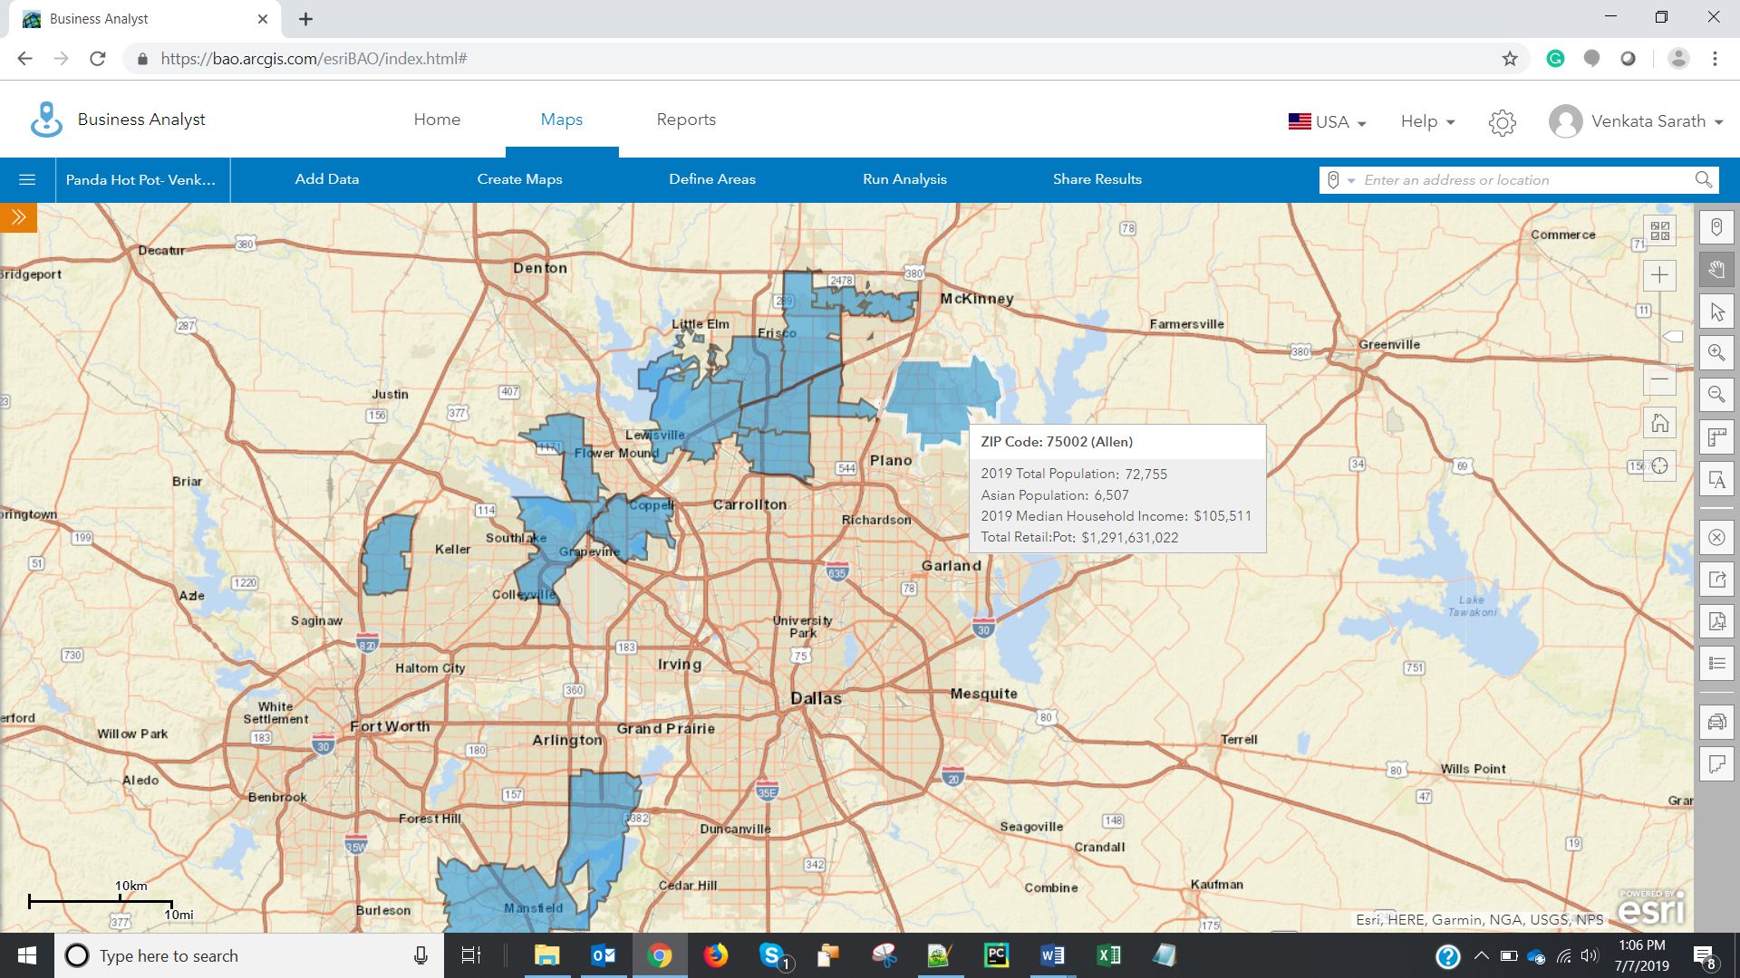

1. Customer Profile 1:



Customer Profile 2:

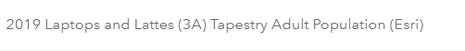

Customer Profile 3:



Customer Profile 4:



Customer Profile 5:

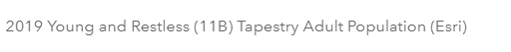

1. Screenshot after placing the sidebars with minimums is:

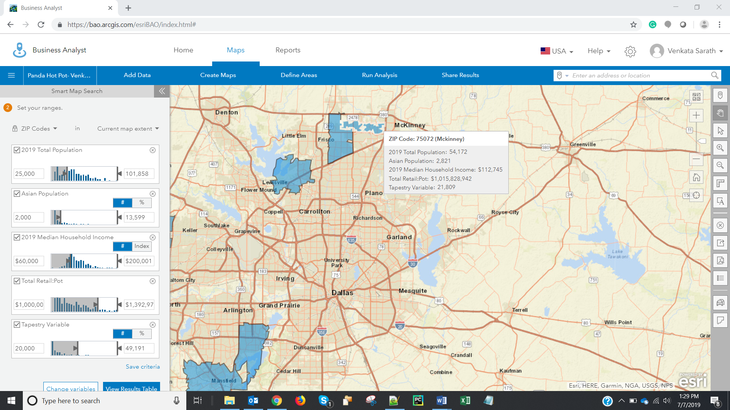

1. Screenshot showing the shortlisted zip codes is:

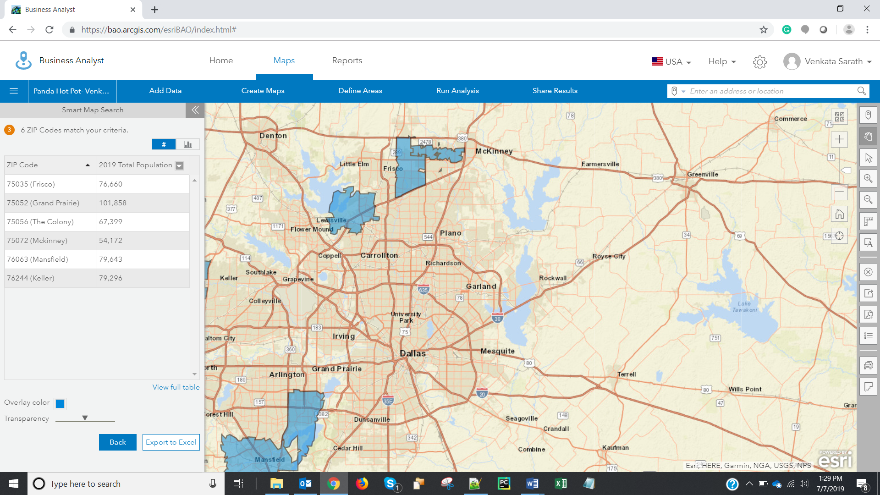

1. Screenshot of the map area is:

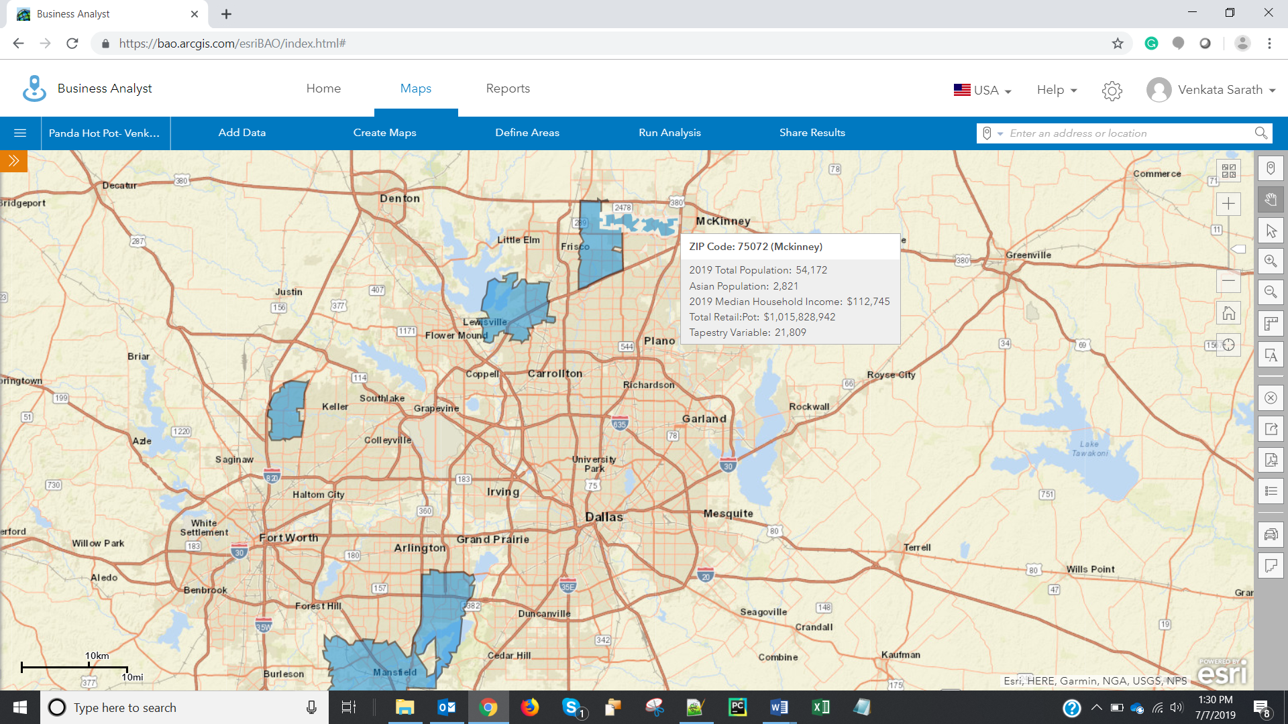

1. Screenshot showing the 3 shortlisted locations is:

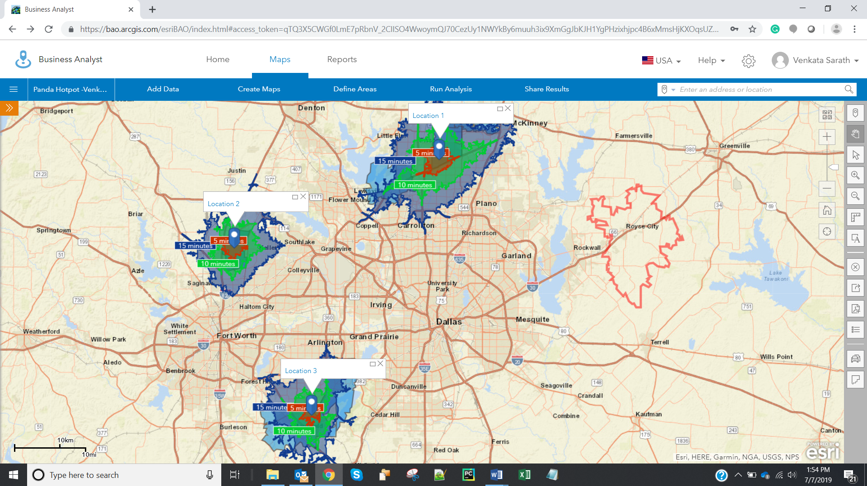

1. Screenshot of the excel workbook is:

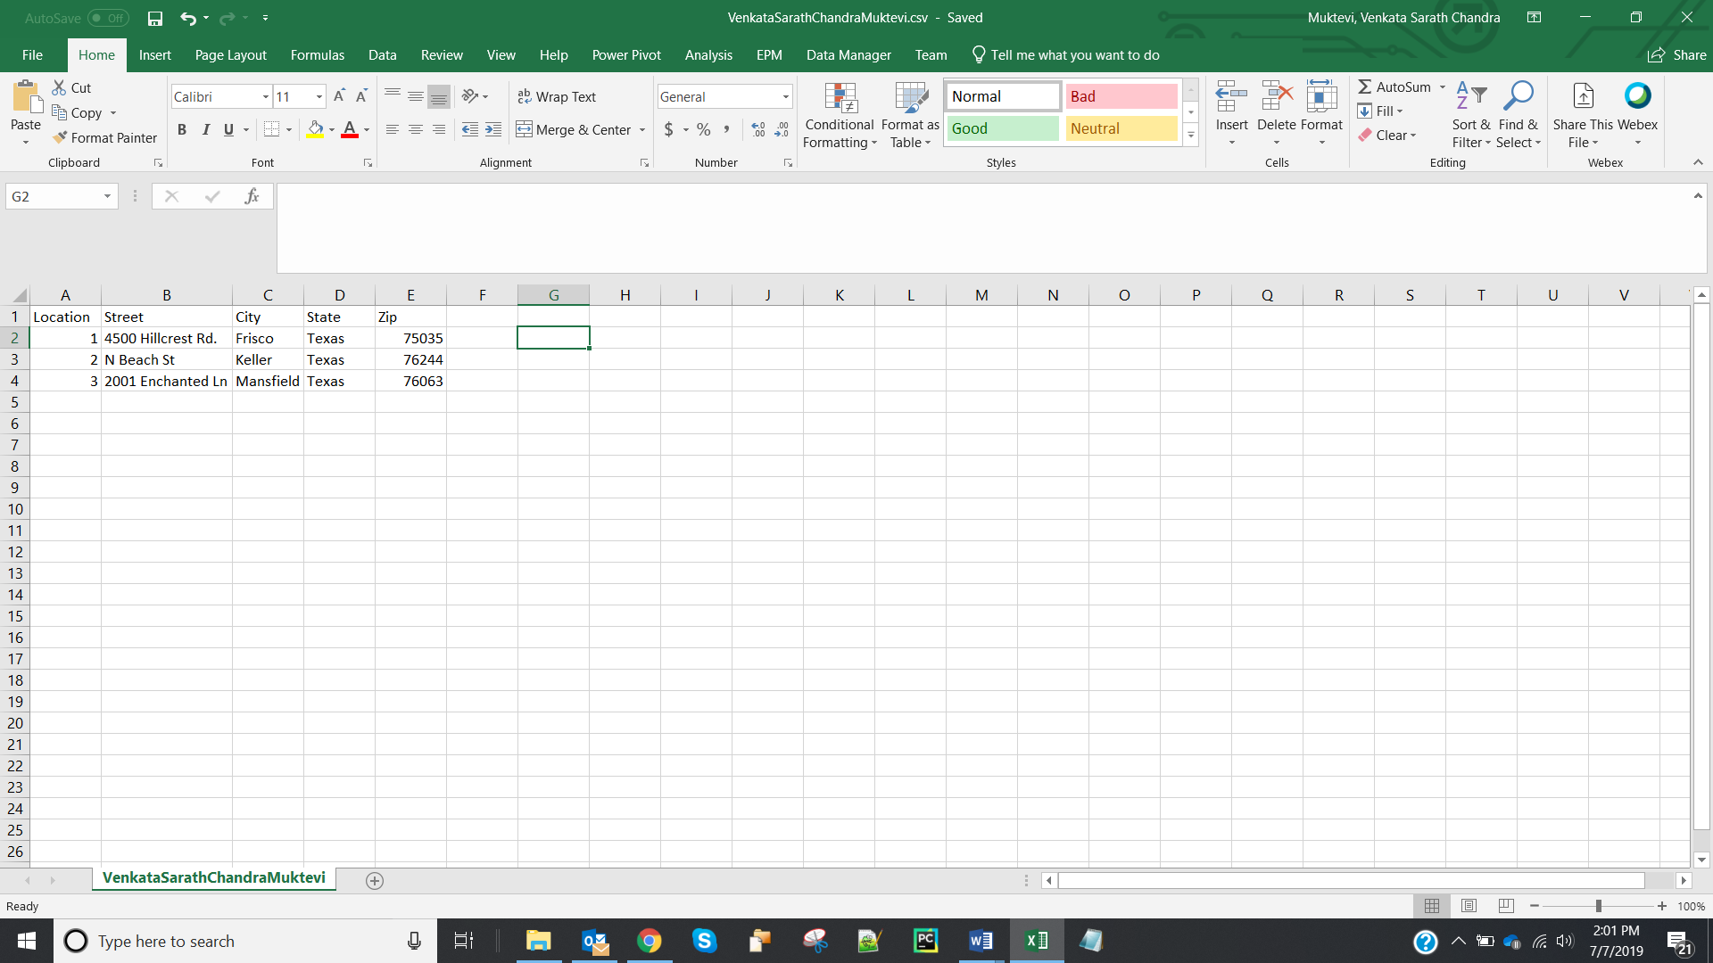

1. Geocoordinates of the three locations are:

Location 1: X: -97.097256 Y: 32.591923

Location 2: X: -97.281308 Y: 32.954013

Location 3: X: -96.787988 Y: 33.115198

1. Screenshot showing the plotted points is:

